Security Risk Identification and Technical Design Analysis

Molly Fraser
18th May 2026
1020 Words
Table of Contents
The Executive Summary 3
Methodology & Tools 5
Scope 5
Scanning Tools 5
Tool Selection 5
Audit Framework 5
Process 5
Assumptions, Limitations, and Timeline 6
Assumptions 6
Limitations 6
Timeline 6
Audit Findings 7
Injection Vulnerabilities (OWASP A03:2021) 7
Broken Access Control (OWASP A01:2021) 7
Security Misconfiguration (OWASP A05:2021) 7
Recommendations & Mitigations 9
4.1 Mitigation of Injection Vulnerabilities 9
4.2 Implementation of Anti-CSRF Protections 9
4.3 Hardening Server Configurations 9
4.4 Lifecycle Management 9
Bibliography 10
Appendix A: OWASP ZAP Automated Dynamic Analysis Report 11
Appendix B: Manual SQL Injection (SQLi) and Authentication Bypass Evidence 12
Appendix C: Web Server Fingerprinting and HTTP Header 13
Appendix D: Nessus Network Security Scan: Infrastructure Overview 14
Appendix E: Nessus Detailed Vulnerability and Service Enumeration 15
Appendix F: NSLookup Results 16

The Executive Summary
Mapping the Data:
Technical reconnaissance and automated scanning revealed that the application is hosted within a Microsoft Azure environment utilising a Cloudflare reverse proxy, yet it lacks essential modern security headers and robust input validation (OWASP, 2025). While the infrastructure is shielded by an external firewall, the application layer remains susceptible to sophisticated attacks due to legacy configurations (NIST, 2024). (See Appendix D: Nessus Network Security Scan: Infrastructure Overview for the network baseline and Appendix C: Web Server Fingerprinting and HTTP Header for evidence of header leakage).
Top 3 Vulnerabilities:
- Injection Risks (SQLi & XSS): Manual testing confirmed that the application accepts un-sanitised database commands and malicious scripts, aligning with known CWE-89 (MITRE, 2026) and CWE-79 (MITRE, 2026) weaknesses. (See Appendix B: Manual SQL Injection (SQLi) and Authentication Bypass Evidence for manual proof).
- Broken Access Control (CSRF): Automated analysis identified the absence of Anti-CSRF tokens on critical endpoints, a vulnerability classified as CWE-352 (MITRE, 2026). (See Appendix A: OWASP ZAP Automated Dynamic Analysis Report).
- Security Misconfiguration (Information Disclosure): The web server is "verbose," leaking specific version information such as ASP.NET 4.0.30319. This exposure of sensitive system data is categorised under CWE-200 (MITRE, 2026). (See Appendix C: Web Server Fingerprinting and HTTP Header and Appendix A: OWASP ZAP Automated Dynamic Analysis Report).
Business & Regulatory Context:
As an e-commerce and user-engagement platform, Supercar Showdown handles Personal Identifiable Information (PII) including names, email addresses, and passwords. Consequently, the business is legally obligated to comply with GDPR (General Data Protection Regulation) (European Union, 2016) regarding data privacy and integrity. The identified injection and access control vulnerabilities represent a significant breach of GDPR’s "Integrity and Confidentiality" principle. Furthermore, if the site processes payments, it must adhere to PCI DSS (Payment Card Industry Data Security Standard) (Barclays Bank, 2026) requirements for secure coding and vulnerability management.
The Bottom Line:
Current vulnerabilities represent a high risk of a total data breach, potential session hijacking, and regulatory non-compliance (OWASP, 2025). Failure to address these application-layer flaws could result in the exposure of the entire user database and the loss of customer trust.

Methodology & Tools

Scope
The target of this security audit is the web application located at hack-yourself-first.com. The audit was conducted on May 1, 2026, utilising an external "black-box" testing approach to simulate a real-world threat actor.

Scanning Tools
Initial passive reconnaissance was performed using the macOS Terminal on the host machine. A nslookup query (See Appendix F: NSLookup Results) identified the target's resolution to two primary IP addresses: 172.67.156.87 and 104.21.89.41. These addresses belong to Cloudflare, confirming the application is protected by an edge-protection and reverse-proxy layer.

Tool Selection
Tool | Justification for Selection | Potential Operational Impact
Nmap | Industry standard for stealthy port discovery and service versioning. | Low; minimal bandwidth consumption.
Nessus | Comprehensive vulnerability assessment tool used to baseline infrastructure risks. | Medium; high-frequency probing can trigger WAF rate-limiting.
OWASP ZAP | Dynamic Application Security Testing (DAST) specifically for web vulnerabilities. | Medium; aggressive active scanning can lead to temporary site instability or DoS.
To mitigate operational impact, scans were conducted using "safe" check modes where possible to ensure the application remained available to other users during the audit.

Audit Framework
To ensure a standardised and repeatable process, this audit utilises the (OWASP, 2025) as the primary framework for identifying and categorising vulnerabilities. This framework ensures that discovered flaws, ranging from Broken Access Control to Security Misconfigurations, are aligned with the most critical current risks to web applications.

Process
A systematic two-step process was followed using a hybridised testing environment consisting of a macOS host and a Kali Linux Virtual Machine running via UTM:
- Infrastructure Mapping (Scans): Active scanning was performed using Nmap for port discovery and Nessus Essentials to baseline the server infrastructure (See Appendix D: Nessus Network Security Scan: Infrastructure Overview and Appendix E: Nessus Detailed Vulnerability and Service Enumeration).
- Pattern-Based Vulnerability Search (Audit): A Dynamic Application Security Testing (DAST) scan was conducted at 07:56:29 using OWASP ZAP 2.17.0. This was supplemented by manual "pattern-based" probing via the Arc Browser developer tools on the host machine to confirm exploitability for SQL Injection and Cross-Site Scripting (See Appendix B: Manual SQL Injection (SQLi) and Authentication Bypass Evidence and Appendix C: Web Server Fingerprinting and HTTP Header).

Assumptions, Limitations, and Timeline

Assumptions
It is assumed that the Cloudflare IP addresses identified represent the total external attack surface for the web application.

Limitations
The presence of Cloudflare’s reverse proxy and WAF (Web Application Firewall) may have obfuscated or blocked aggressive scan payloads, potentially masking additional backend vulnerabilities.

Timeline
Phase 1: Reconnaissance (1 Hour): Passive footprinting and nslookup queries.
Phase 2: Infrastructure Scanning (2 Hours): Nmap port mapping and Nessus vulnerability enumeration.
Phase 3: Web Audit & Manual Probing (2 Hours): OWASP ZAP DAST scan followed by manual validation of SQLi and XSS.
Phase 4: Evaluation & Reporting (3 Hours): Analysis of logs and documentation of findings.

Audit Findings

Injection Vulnerabilities (OWASP A03:2021)
Finding: Cross-Site Scripting (XSS) and SQL Injection (SQLi)
Technical Detail: Manual probing of the "Comments" section revealed that the application does not properly sanitise user input. This failure to validate input before processing allows for the execution of unauthorised commands, a high-risk flaw described in the OWASP Injection Prevention Cheat Sheet (OWASP, 2026).
Manual Evidence: As seen in Appendix B: Manual SQL Injection (SQLi) and Authentication Bypass Evidence a JavaScript payload was successfully injected, which is evidenced by the browser console showing an attempt to execute the script.
Database Impact: The application also accepts SQL syntax (e.g., ' OR 1=1--) in name fields, which are then stored and displayed by the database.
Risk: High. These vulnerabilities allow for potential session hijacking and full data exfiltration of the user database.

Broken Access Control (OWASP A01:2021)
Finding: Absence of Anti-CSRF Tokens
Technical Detail: Automated analysis identified that the application fails to implement anti-Cross-Site Request Forgery (CSRF) tokens on critical pages, such as /Account/Register.
Evidence: The scan report confirms that five separate instances of this vulnerability were found. Per the (MITRE, 2026) definition of CWE-352, the lack of unique tokens allows for unauthorised requests to be processed as if they were legitimate user actions.
Risk: Medium. An attacker could craft a malicious link that forces a logged-in user to perform unauthorised registration or account changes without their knowledge. (Appendix A: OWASP ZAP Automated Dynamic Analysis Report).

Security Misconfiguration (OWASP A05:2021)
Finding: Verbose Header Leakage and Missing Security Headers
Technical Detail: The web server is configured to be "verbose," meaning it leaks specific technology stack information in the HTTP response headers.
Evidence: Appendix C: Web Server Fingerprinting and HTTP Header shows the server disclosing X-AspNet-Version: 4.0.30319 and X-Powered-By: ASP.NET.
Missing Protections: The ZAP report also flagged a missing Content Security Policy (CSP) and Anti-clickjacking headers (X-Frame-Options).
Risk: Low to Medium. This information disclosure provides attackers with the exact software versions needed to find specific, unpatched exploits, failing to meet the "Protect" function requirements of the (NIST, 2024) framework. (Appendix A: OWASP ZAP Automated Dynamic Analysis Report)

Recommendations & Mitigations
To reduce the current high-risk profile of hack-yourself-first.com, the following technical controls should be implemented:

4.1 Mitigation of Injection Vulnerabilities
Implement Output Encoding: To stop Cross-Site Scripting (XSS), the application must encode all user-supplied data before it is rendered in the browser (OWASP, 2026).
Utilise Parameterised Queries: To prevent SQL Injection, developers must use prepared statements. This is the primary defence recommended by (OWASP, 2025) to ensure the database treats input as data, not code.

4.2 Implementation of Anti-CSRF Protections
Enforce Anti-Forgery Tokens: The application should include a unique, cryptographically strong token in every state-changing request (such as registration and login).
Verification: The server must verify this token before processing any request to ensure the action was intentionally initiated by the user. (See Appendix A: OWASP ZAP Automated Dynamic Analysis Report).

4.3 Hardening Server Configurations
Disable Verbose Headers: Configure the web server to suppress headers to prevent technology fingerprinting, adhering to NIST SP 800-53 security controls for system and information integrity (NIST, 2024). (Refer to Appendix C: Web Server Fingerprinting and HTTP Header and Appendix A: OWASP ZAP Automated Dynamic Analysis Report).
Deploy Security Headers:
Content Security Policy (CSP): Implement a robust CSP to restrict where scripts can be loaded from, significantly reducing XSS impact.
X-Frame-Options: Set this header to DENY or SAMEORIGIN to prevent clickjacking attacks.
HTTP Strict Transport Security (HSTS): Implement HSTS to ensure all connections are made over HTTPS.

4.4 Lifecycle Management
Patch Management: The outdated jQuery library identified by the scanner must be updated to the latest stable version to eliminate known vulnerabilities. (See Appendix A: OWASP ZAP Automated Dynamic Analysis Report).

Bibliography
MITRE, 2026. CWE-200: Exposure of Sensitive Information to an Unauthorized Actor. [Online]
Available at: https://cwe.mitre.org/data/definitions/200.html
[Accessed 1 May 2026].
MITRE, 2026. CWE-352: Cross-Site Request Forgery (CSRF). [Online]
Available at: https://cwe.mitre.org/data/definitions/352.html
[Accessed 1 May 2026].
MITRE, 2026. CWE-79: Improper Neutralization of Input During Web Page Generation ('Cross-site Scripting'). [Online]
Available at: https://cwe.mitre.org/data/definitions/79.html
[Accessed 1 May 2026].
MITRE, 2026. CWE-89: Improper Neutralization of Special Elements used in an SQL Command ('SQL Injection'). [Online]
Available at: https://cwe.mitre.org/data/definitions/89.html
[Accessed 1 May 2026].
NIST, 2024. The NIST Cybersecurity Framework (CSF) 2.0. [Online]
Available at: https://nvlpubs.nist.gov/nistpubs/CSWP/NIST.CSWP.29.pdf
[Accessed 1 May 2026].
OWASP, 2025. OWASP Top 10:2025. [Online]
Available at: https://owasp.org/Top10/2025/
[Accessed 1 May 2026].
OWASP, 2026. Injection Prevention Cheat Sheet. [Online]
Available at: https://cheatsheetseries.owasp.org/cheatsheets/Injection_Prevention_Cheat_Sheet.html
[Accessed 1 May 2026].

Appendix A: OWASP ZAP Automated Dynamic Analysis Report
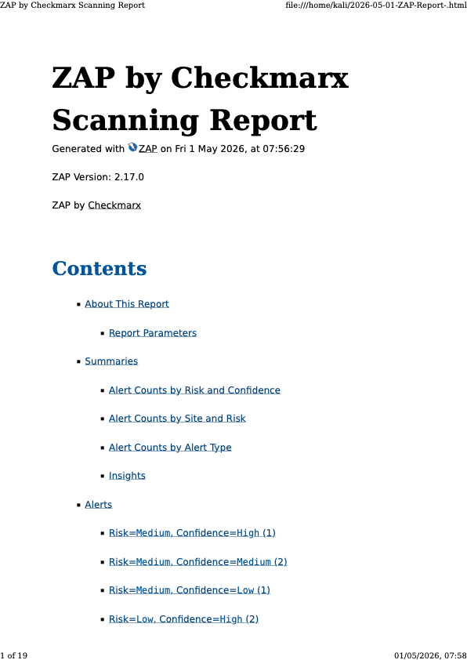

Appendix B: Manual SQL Injection (SQLi) and Authentication Bypass Evidence
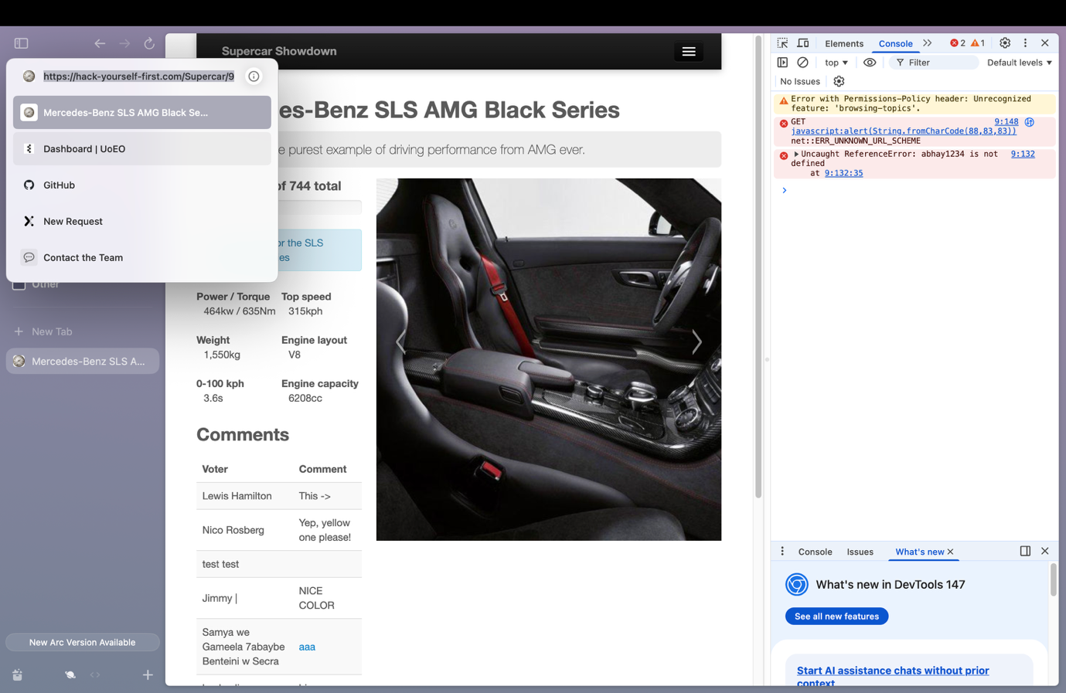

Appendix C: Web Server Fingerprinting and HTTP Header
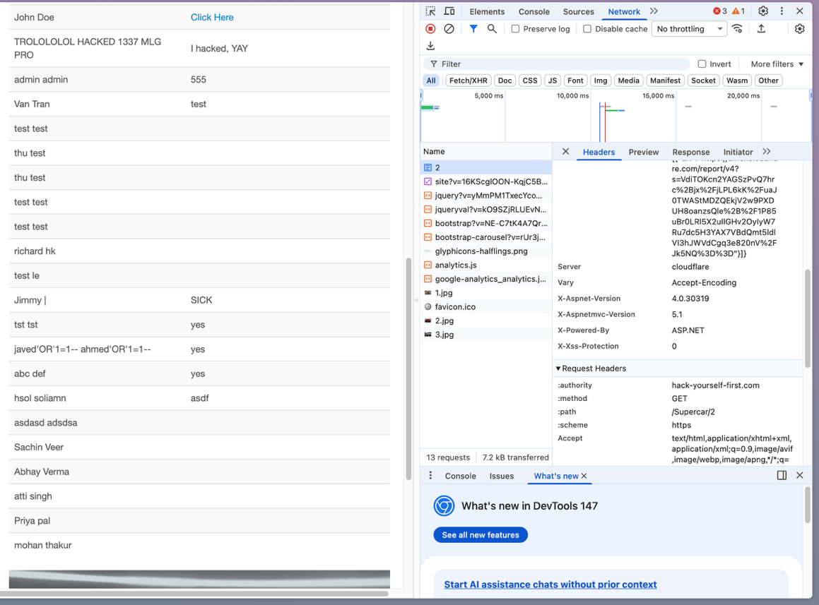

Appendix D: Nessus Network Security Scan: Infrastructure Overview
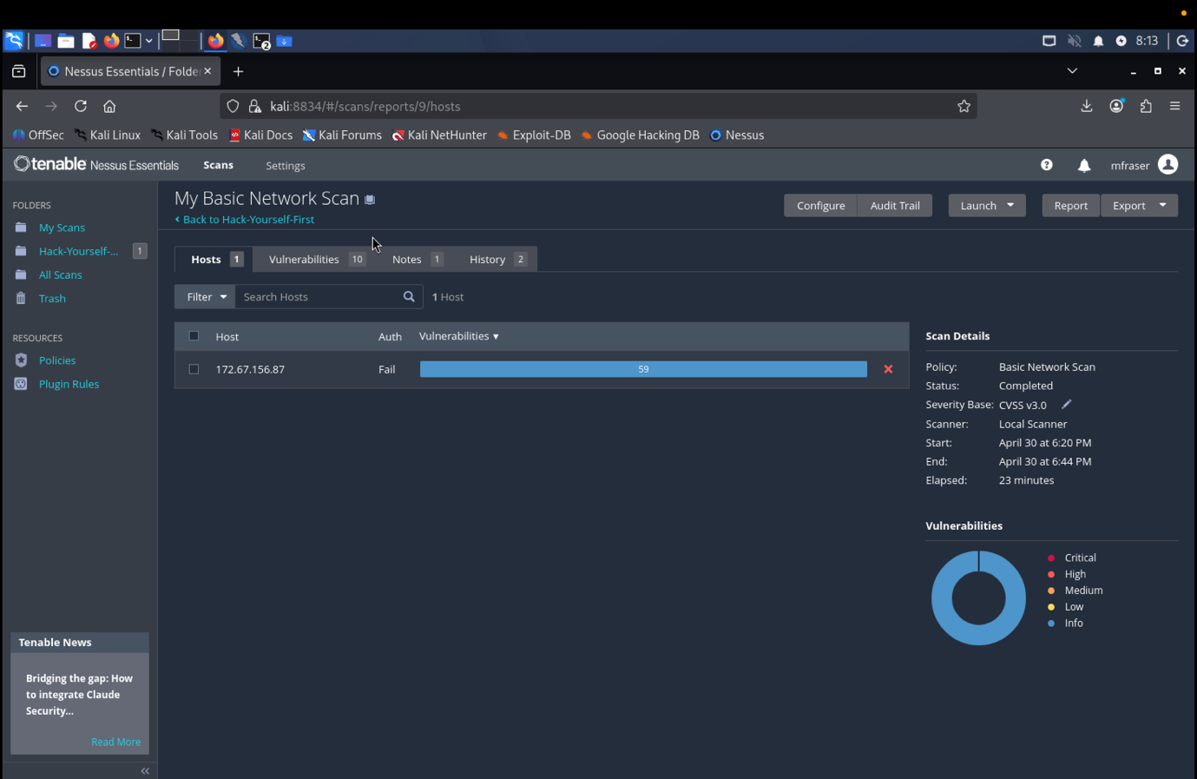

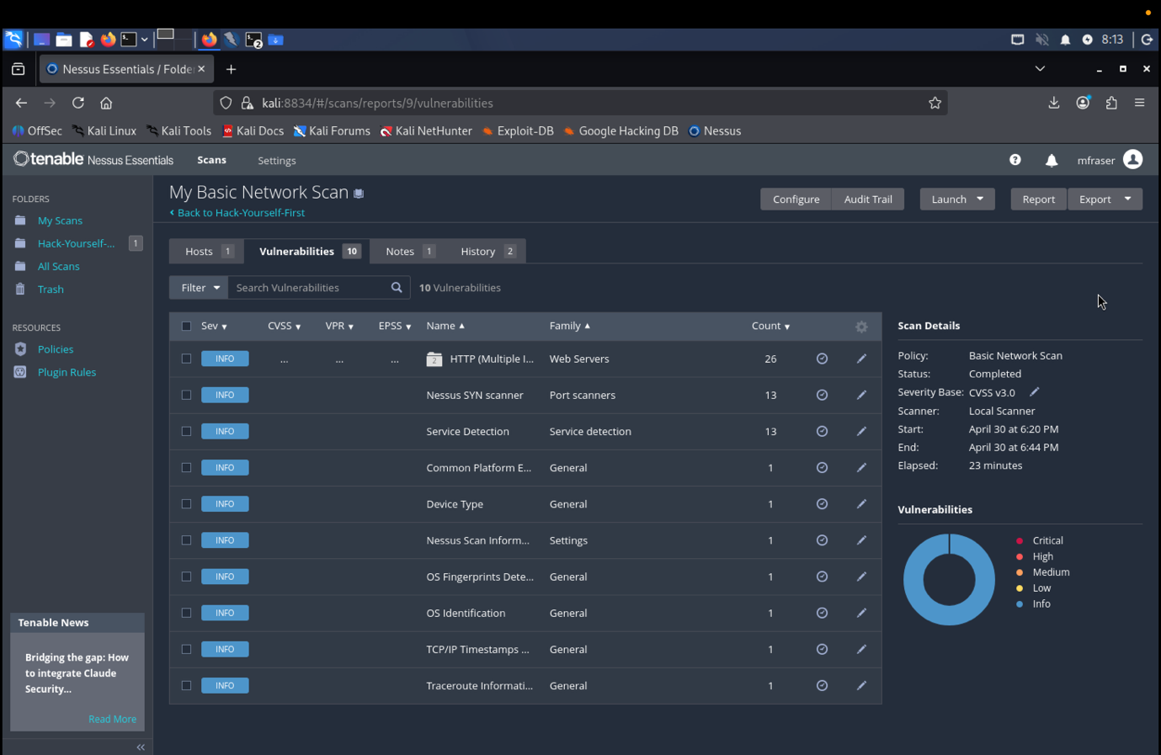
Appendix E: Nessus Detailed Vulnerability and Service Enumeration

Appendix F: NSLookup Results

